Add your logo here |  | 

Self-Evaluation Report for
[Add name of CPD Course in English]

Details
APPLICANT DETAILS
Course title
Name of Organisation/Institution:

Address:
Name and role of person filling out this application:
Contact email:
Course URL:
Contact email used for prospective participants:
Date(s) of Course:
Date of This Application:

INTRODUCTION

1. Course Aims and Decision-Making

1.1. Course Aims, Outcomes, Distinctiveness & Social Accountability

Criterion
The course clearly articulates its aims, learning outcomes and distinctiveness, indicating alignment with the host institution’s mission and demonstrating that it serves an identified need with intended impact on learners and professional practice.

Guidance
Applicants should describe the main aims of the course and what it is intended to achieve for learners in terms of knowledge, skills or professional growth. Explain how these aims support or complement the strategic goals or values of the host institution. Clearly outline the intended learning outcomes and explain how these are relevant, measurable and aligned with the course’s purpose and the needs of the intended audience. Additionally, reflect on what distinguishes the course, for example, whether through innovative content, teaching methods, delivery formats or a specific target audience. Emphasise the most significant outcomes or impacts the course aims to deliver, such as workforce development, community engagement or policy influence.
Narrative:

1.2. Organisation & Decision Making

Criterion
The course is supported by a clear organisational structure, with designated leadership and active stakeholder involvement to ensure effective design, approval delivery, accountability and continuous development.

Guidance
Applicants should explain how the course fits into the institution’s organisational framework, including any relevant departments, units or centres. Clarify who is responsible for organising, approving and overseeing the course and summarise their key roles in ensuring quality and relevance. Identify the stakeholders involved, such as trainers, professional bodies, external partners, participants and explain how they contribute to course design, delivery or review. Emphasise how this collaboration ensures the course meets professional development needs, aligns with institutional goals and reflects current public health priorities.
Narrative:

2. Participants and Engagement

2.1. Audience & Admissions

Criterion
The targeted audience and admission / registration processes are clearly defined, transparent, inclusive and appropriate to the course aims and outcomes. Appropriate outreach and criteria ensure participants are suitably prepared to benefit from the learning experience.

Guidance
Applicants should clearly define the intended audience, outlining the professional backgrounds, roles or sectors the course is designed to support. Describe the entrance requirements and how prospective learners can apply. Explain the steps in place to assess applications fairly, consistently and in line with the course’s objectives. If there is a limit on participant intake, outline how this is determined, such as resource availability, optimal group sizes or delivery format.
Narrative:

2.2. Learning & Assessment

Criterion
The course is designed and delivered using appropriate, inclusive and evidence-based learning methods, with clear outcomes, structured content and assessment (where applicable) that supports the application of learning in practice.

Guidance
Describe the teaching methods and delivery formats used, whether in-person, online or hybrid and explain how these approaches enhance accessibility and engagement. Provide an overview of the course structure and sequence, including a brief timetable if applicable. If assessments are used, explain how they support and measure the achievement of learning outcomes. Finally, highlight how learning is designed to be applied in practice, for example, reflection or practical exercises and how innovation, whether through content, delivery or technology, is integrated.
* Much of this criterion may already be included in Course / Programme Handbook. If so please refer.
Narrative:

2.3. Participation & Awards

Criterion
The course clearly defines learner participation, recognises engagement through appropriate certification or CPD credit and ensures transparency in how these awards are calculated, issued and recognisable.

Guidance
Applicants should describe the types of learning engagement offered, such as, trainer-led sessions, group work or self-directed study and explain how participation is distributed across these formats. Clarify whether a certificate is awarded upon completion, who issues it and what conditions must be met. Where relevant, outline if the CPD issues a certificate and by whom. Reflect on how these certificates or points are recognised professionally, nationally or by other institutions.
Narrative:

3. Resources

3.1. Human & Physical Resources

Criterion
The course is supported by suitably qualified trainers and appropriate physical, digital and learning resources that are adequate and relevant to meet its stated aims, outcomes and participant needs.

Guidance
Applicants should describe who the core trainers are, highlighting how their qualifications and experience align with the course’s objectives and content. Outline the support roles in place, such as administrative, technical or facilitation staff and explain how these roles contribute to effective course delivery. Provide an overview of the core learning materials or texts used and how they support the intended outcomes. Additionally, describe any supplementary resources available to enhance the learning experience, such as access to online platforms, simulations, specialised equipment, academic literature or databases.
Narrative:

3.2. Public Information

Criterion
Courses ensure clear, accurate, objective, up-to-date and easily accessible information is available for prospective participants, stakeholders and the public at large.

Guidance
Applicants should provide clear and detailed information about their CPD programmes in public health. This should include the courses offered, the intended audience, learning outcomes, the structure and duration of the courses and the type of certification awarded upon completion.
Narrative:

4. Quality Assurance, Financing and Integrity

4.1. Quality Assurance & Enhancement

Criterion
The course operates within a clear system of quality assurance and enhancement that ensures regular review, integrates stakeholder feedback and supports continuous improvement in line with evolving workforce needs and public health priorities.

Guidance
Applicants should describe their approach to quality assurance and enhancement, including who is responsible for oversight and how the processes are implemented. Explain how the course is regularly reviewed (internally or externally) to ensure it remains relevant, effective and responsive to evolving public health and workforce needs. Describe how feedback from learners, staff and external stakeholders is systematically gathered and used to inform course improvements. Additionally, reflect on how benchmarking, external review processes or formal accreditations have shaped the design, delivery or refinement of the course.
Narrative:

4.2. Financing & Conflicts Of Interest

Criterion
The course is transparently financed and implements safeguards to ensure it is free from undue commercial influence or conflicts of interest, protecting the integrity and independence of its educational content.

Guidance
Applicants should describe how the course is financed, including key sources of income such as participant fees, grants or sponsorships. Clearly explain the steps taken to identify, declare and manage any potential conflicts of interest, particularly where external funding or partnerships are involved. Detail how the integrity of the course is safeguarded, ensuring that commercial or financial interests do not influence the course content, learning outcomes or delivery. This may include internal policies, review processes or declaration requirements for trainers and contributors.
Narrative:

5. SWOT Analysis; Improvement Plan
Provide a short (1 page maximum) SWOT analysis (Strengths, Weaknesses, Opportunities and Threats) of the CPD Course / event. This analytical document should include:
- Review/reflect on the strategic goals of your Course.
- Analyse its strengths and weaknesses (factors intrinsic to the Course which enable or hinder the achievement of strategic goals).
- Identify opportunities and threats (external factors which can positively or negatively affect main goals)
Propose an improvement plan for your Course which answers the following questions:
- What changes are planned to achieve the main objectives?
- Do the improvement proposals address the weaknesses?
- Are those proposals supported by the strengths?
- Priority and time for implementation
- Indicators of implementation

Supporting Evidence Checklist
- ☐ Course / Programme Handbook (or other material which indicates the following): Course timetable; topics; learning outcomes; training methods; modes of delivery and assessments (where applicable)
- ☐ Trainer CVs or short bios outlining relevant experience.
- ☐ (if not in Handbook) List of learning materials or access to a reading/resource guide.
- ☐ Summary of Internal review reports or quality improvement plans
- ☐ Provide a copy of your conflict of interest policy, if available.
- Other relevant documents

ANNEX A. W.H.O. Essential Public Health Functions Monitoring
See EPHF Monitoring Handbook (under generic resources here) for details on how to complete this document

Target Audience
☐ | Public Health Personnel (1)
☐ | Health and Care Workers (2)
☐ | Occupations Allied to Health (3)
☐ | Senior Specialists (4)
☐ | Policy Authority (5)

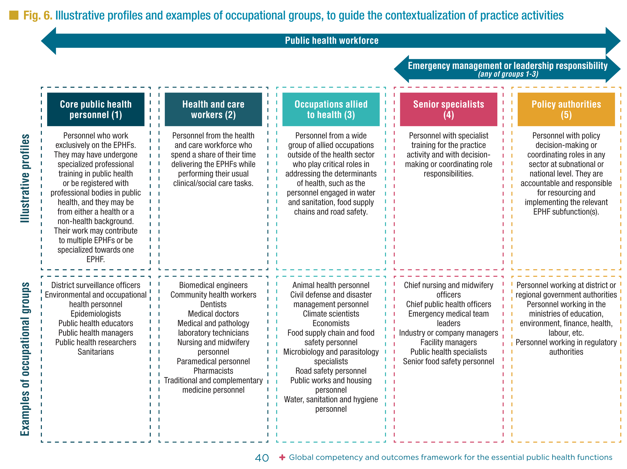

Course Mapping to W.H.O. EPHF Monitoring
COURSE TITLE | W.H.O. ESSENTIAL PUBLIC HEALTH FUNCTIONS
 | 1☐ | 2 ☐ | 3☐ | 4 ☐ | 5 ☐ | 6☐
 | 7 ☐ | 8 ☐ | 9☐ | 10 ☐ | 11 ☐ | 12 ☐

Competencies
Please use check boxes to indicate which ones exist in your programme or course.
Competency domain I: Community-centredness
Competencies rooted in community-centred approaches to public health that promote equity, increase people’s control over their health and lives and mobilize community assets.
☐ | - Promotes health equity among individuals and communities
☐ | - Enables people to increase control over, and to improve, their health and lives
☐ | - Fosters inclusive and participatory approaches to public health that embrace cultural  diversity and inclusion
Competency domain II: Decision-making
Competencies relating to the approach to individual decision-making in daily practice, and contribution to collective decision-making mechanisms, that embody the ethics and values of public health.
☐ | - Takes an evidence-informed approach to decision-making
☐ | - Applies systems thinking to public health problem-solving
☐ | - Adapts to unexpected or rapidly changing situations
Competency domain III: Communication
Competencies relating to an individual’s interactions with individuals, communities, partners and others, and their individual contributions to public health goals.
☐ | - Communicates actively and attentively
☐ | - Conveys information purposefully, including through trusted sources and key partners
☐ | - Adapts communication to the contextual goals, needs, urgency and sensitivity of the  situation
Competency domain IV: Collaboration
Competencies relating to the public health approaches rooted in diplomatic collaborations with communities and stakeholders across sectoral and geographical boundaries, as part of whole-of-society and whole-of-government approaches.
☐ | - Engages in collaborative practice within and between defined teams
☐ | - Engages in collaborative practice within partnerships and coalitions
☐ | - Learns from, with and about others
☐ | - Constructively manages tensions, conflicts, resistance and opposition
Competency domain V: Evidence-informed practice
Competencies relating to the generation and application of evidence to public health practice.
☐ | - Assesses data, information and evidence from a range of sources
☐ | - Promotes evidence-informed public health practice
☐ | - Contributes to continuous quality improvement
Competency domain VI: Personal conduct
Competencies relating to self-governed behaviours.
☐ | - Works within the limits of competence and role responsibilities
☐ | - Demonstrates high standards of ethical conduct
☐ | - Engages in lifelong learning
☐ | - Adopts strategies to manage one’s own health and well-being

Feedback on EPHF Monitoring
Thank you once again for completing this monitoring form. We would now greatly appreciate your honest feedback so we can feed this back as well.
Name: Position:

1. General
- How easy or difficult was it to understand the monitoring questionnaire?
☐ Very Difficult | ☐ Difficult | ☐ neither difficult nor easy | ☐ Easy | ☐ Very Easy
- How easy or difficult was it to complete the monitoring questionnaire?
☐ Very Difficult | ☐ Difficult | ☐ neither difficult nor easy | ☐ Easy | ☐ Very Easy
- Approximately how long did it take you to complete?
☐ less than 10 minutes | ☐ 10 to 20 minutes | ☐ 20 Minutes plus
- Did you find any section particularly challenging or unclear? (Open-ended)

2. Content and Clarity
- Did the target audience capture your target? If not, please explain how they could be improved?
☐ Yes | No (please explain)
- Likewise, did the competences address your competences? For example, did any of the competences feel redundant or unnecessary? If so, please explain how they could be improved.
☐ Yes | No (please explain)
- And with the EPHFs, did they reflect your activity? Did any feel unnecessary or any areas missing?
☐ Yes | No (please explain)

4. Relevance and Applicability
- Were the questions relevant to you and your programme?
☐ Yes | No (please explain)

5. Suggestions for Improvement
- Do you have any other comments or recommendations to improve the questionnaire?



