

EPHF & Competency Monitoring Template

Section 1: Programme Details
Programme title
Faculty / Department
Awarding Body/Host Institution
Address:
Name and role of person filling out this application:
Contact email:
Programme URL:
Date:

Contents

Target Audience 3
Competencies of public health workers 4
Programme Mapping to W.H.O. EPHF Monitoring 5
Feedback 6

Target Audience

Target Audience
☐ | Public Health Personnel (1)
☐ | Health and Care Workers (2)
☐ | Occupations Allied to Health (3)
☐ | Senior Specialists (4)
☐ | Policy Authority (5)

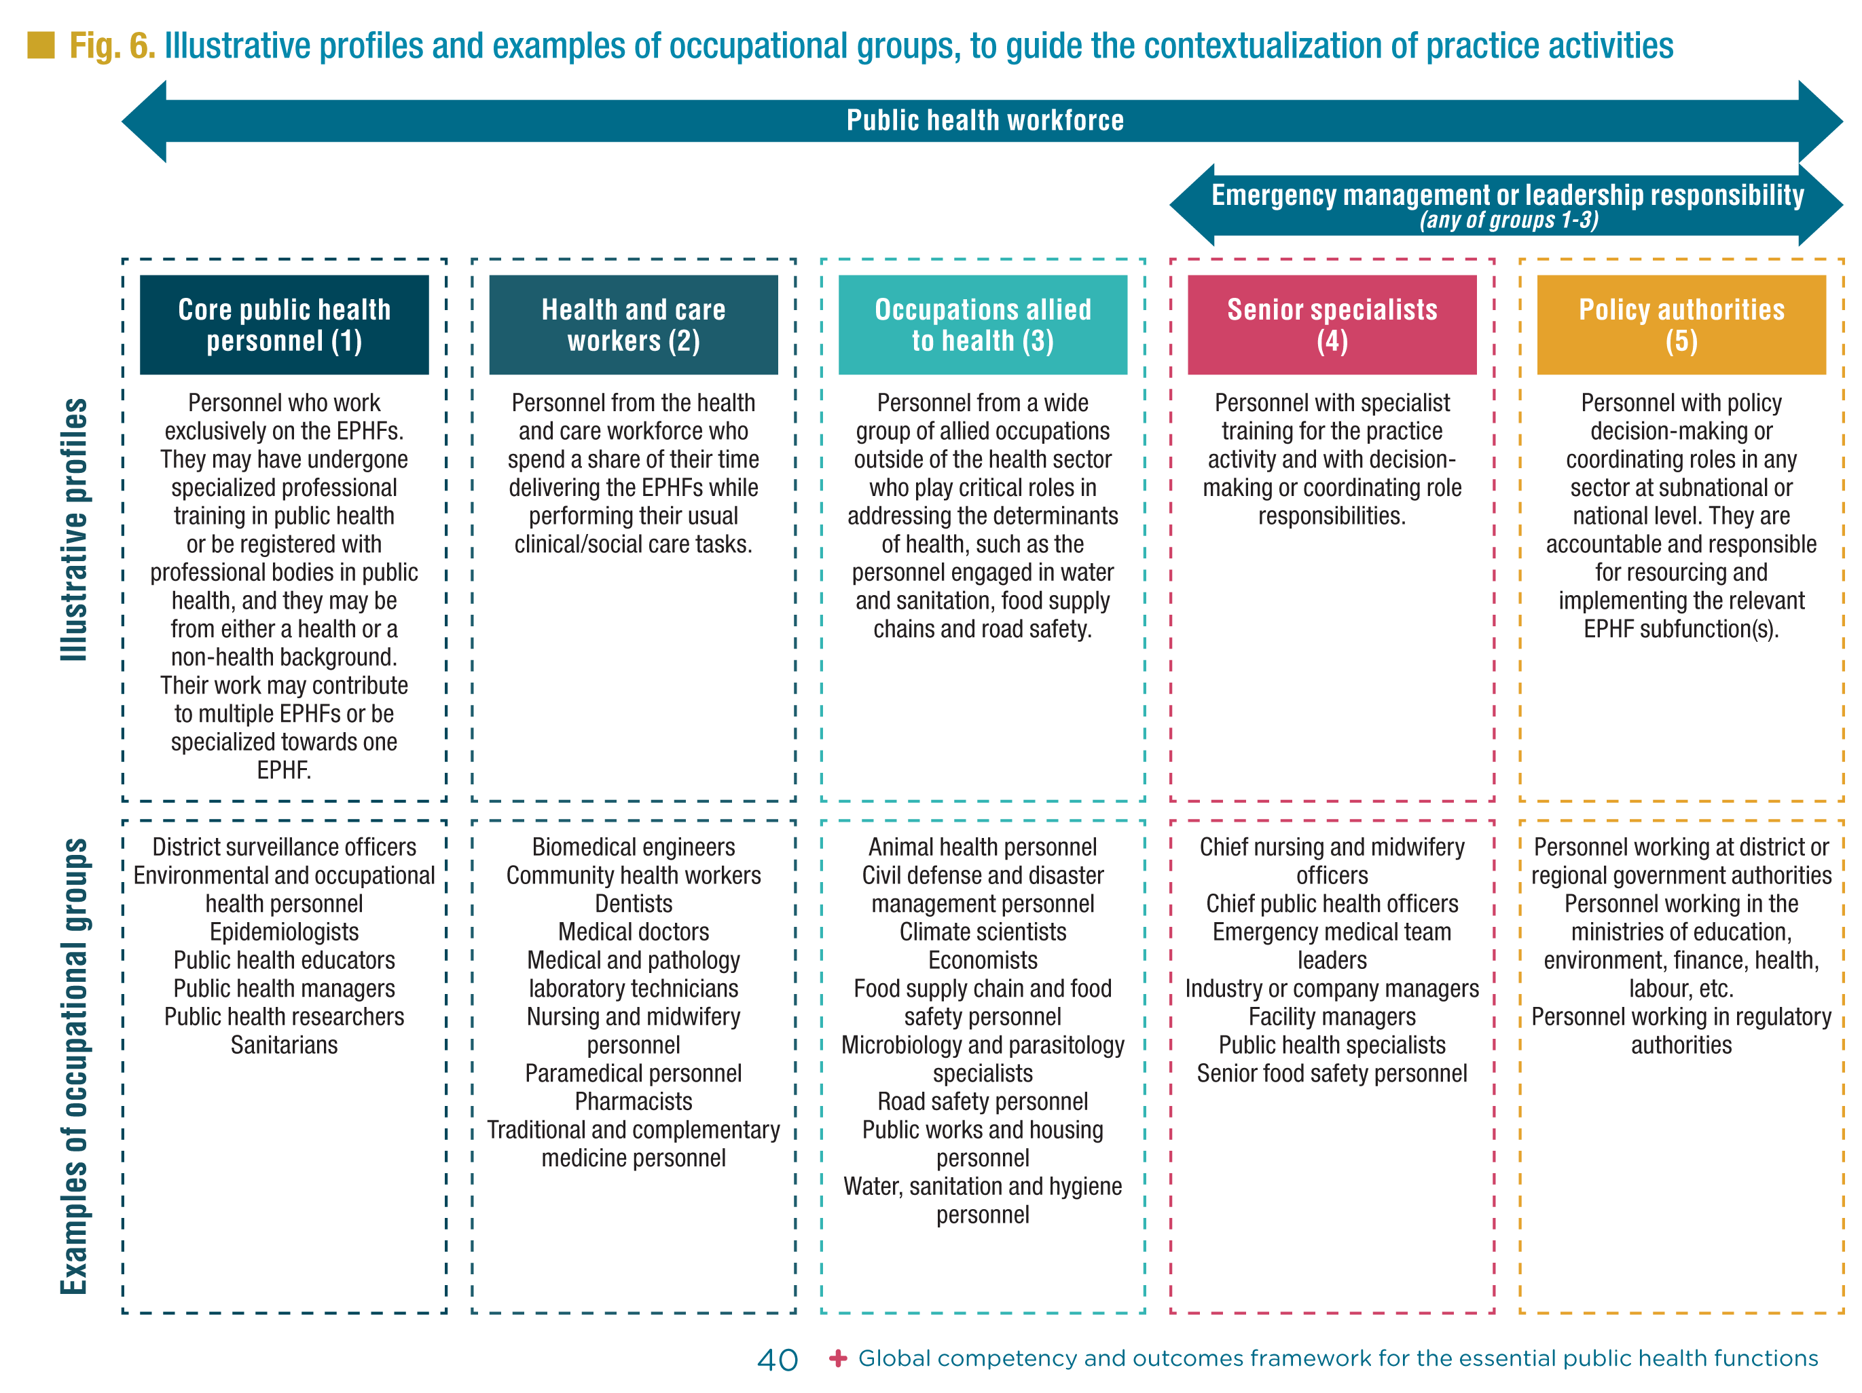

Competencies of public health workers
The 20 competencies organized into six domains listed below are interrelated and interdependent. Please use check boxes to indicate which ones exist in your programme or course.
Competency domain I: Community-centredness
Competencies rooted in community-centred approaches to public health that promote equity, increase people’s control over their health and lives and mobilize community assets.
☐ | - Promotes health equity among individuals and communities
☐ | - Enables people to increase control over, and to improve, their health and lives
☐ | - Fosters inclusive and participatory approaches to public health that embrace cultural  diversity and inclusion
Competency domain II: Decision-making
Competencies relating to the approach to individual decision-making in daily practice, and contribution to collective decision-making mechanisms, that embody the ethics and values of public health.
☐ | - Takes an evidence-informed approach to decision-making
☐ | - Applies systems thinking to public health problem-solving
☐ | - Adapts to unexpected or rapidly changing situations
Competency domain III: Communication
Competencies relating to an individual’s interactions with individuals, communities, partners and others, and their individual contributions to public health goals.
☐ | - Communicates actively and attentively
☐ | - Conveys information purposefully, including through trusted sources and key partners
☐ | - Adapts communication to the contextual goals, needs, urgency and sensitivity of the  situation
Competency domain IV: Collaboration
Competencies relating to the public health approaches rooted in diplomatic collaborations with communities and stakeholders across sectoral and geographical boundaries, as part of whole-of-society and whole-of-government approaches.
☐ | - Engages in collaborative practice within and between defined teams
☐ | - Engages in collaborative practice within partnerships and coalitions
☐ | - Learns from, with and about others
☐ | - Constructively manages tensions, conflicts, resistance and opposition
Competency domain V: Evidence-informed practice
Competencies relating to the generation and application of evidence to public health practice.
☐ | - Assesses data, information and evidence from a range of sources
☐ | - Promotes evidence-informed public health practice
☐ | - Contributes to continuous quality improvement
Competency domain VI: Personal conduct
Competencies relating to self-governed behaviours.
☐ | - Works within the limits of competence and role responsibilities
☐ | - Demonstrates high standards of ethical conduct
☐ | - Engages in lifelong learning
☐ | - Adopts strategies to manage one’s own health and well-being

Programme Mapping to W.H.O. EPHF Monitoring.
 | W.H.O. ESSENTIAL PUBLIC HEALTH FUNCTIONS
CORE / COMPULSORY MODULES | 1 | 2 | 3 | 4 | 5 | 6 | 7 | 8 | 9 | 10 | 11 | 12
 | ☐ | ☐ | ☐ | ☐ | ☐ | ☐ | ☐ | ☐ | ☐ | ☐ | ☐ | ☐
 | ☐ | ☐ | ☐ | ☐ | ☐ | ☐ | ☐ | ☐ | ☐ | ☐ | ☐ | ☐
 | ☐ | ☐ | ☐ | ☐ | ☐ | ☐ | ☐ | ☐ | ☐ | ☐ | ☐ | ☐
 | ☐ | ☐ | ☐ | ☐ | ☐ | ☐ | ☐ | ☐ | ☐ | ☐ | ☐ | ☐
 | ☐ | ☐ | ☐ | ☐ | ☐ | ☐ | ☐ | ☐ | ☐ | ☐ | ☐ | ☐
 | ☐ | ☐ | ☐ | ☐ | ☐ | ☐ | ☐ | ☐ | ☐ | ☐ | ☐ | ☐

OPTIONAL / ELECTIVE MODULES | 1 | 2 | 3 | 4 | 5 | 6 | 7 | 8 | 9 | 10 | 11 | 12
 | ☐ | ☐ | ☐ | ☐ | ☐ | ☐ | ☐ | ☐ | ☐ | ☐ | ☐ | ☐
 | ☐ | ☐ | ☐ | ☐ | ☐ | ☐ | ☐ | ☐ | ☐ | ☐ | ☐ | ☐
 | ☐ | ☐ | ☐ | ☐ | ☐ | ☐ | ☐ | ☐ | ☐ | ☐ | ☐ | ☐
 | ☐ | ☐ | ☐ | ☐ | ☐ | ☐ | ☐ | ☐ | ☐ | ☐ | ☐ | ☐
Add rows as required

Feedback
Thank you once again for completing this monitoring form. We would now greatly appreciate your honest feedback so we can feed this back as well.
Name: Position:
1. General
- How easy or difficult was it to understand the monitoring questionnaire?
☐ Very Difficult | ☐ Difficult | ☐ neither difficult nor easy | ☐ Easy | ☐ Very Easy
- How easy or difficult was it to complete the monitoring questionnaire?
☐ Very Difficult | ☐ Difficult | ☐ neither difficult nor easy | ☐ Easy | ☐ Very Easy
- Approximately how long did it take you to complete? (e.g., Less than 10 min, 10–20 min, 20+
☐ less than 10 minutes | ☐ 10 to 20 minutes | ☐ 20 Minutes plus
- Did you find any section particularly challenging or unclear? (Open-ended)
Some of the competences weren’t realty applicable to our programme

2. Content and Clarity
- Did the target audience capture your target? If not, please explain how they could be improved?
☐ Yes | No (please explain)
- Likewise, did the competences address your competences? For example, did any of the competences feel redundant or unnecessary? If so, please explain how they could be improved.
☐ Yes | No (please explain)
- And with the EPHFs, did they reflect your activity? Did any feel unnecessary or any areas missing?
☐ Yes | No (please explain)

4. Relevance and Applicability
- Were the questions relevant to you and your programme?
☐ Yes | No (please explain)

5. Suggestions for Improvement
- Do you have any other comments or recommendations to improve the questionnaire?



